**StreamSets App Installation Guide**

Stephen Blystone ([smb032100@utdallas.edu](mailto:smb032100@utdallas.edu))

Document Version 1.0

Last Updated: Apr 6, 2018

Table of Contents

**Revision History** 3

**Big Data Pipeline Architecture** 3

**Pre-Requisites** 4

**Installing and Configuring Apache Kafka** 4

**Installing and Configuring Apache Spark** 4

**Installing and Configuring Elasticsearch** 4

**Installing StreamSets** 5

**Building Pipeline in StreamSets** 5

**Testing Current Pipeline** 6

**Stopping Current Pipeline** 7

**Installing Apache Spark** 10

**Testing Apache Spark Streaming** 10

**Setting up Apache Spark Streaming** 11

**Setting up Apache Spark SQL** 11

**Streaming Applications** 11

# **Revision History**

|  |  |  |
| --- | --- | --- |
| **Version** | **Date** | **Changes** |
| 1.0 | 4/6/2018 | Initial Version |

# **Big Data Pipeline Architecture**

Below is a basic Big Data architecture for real-time processing from the Microsoft website. We are taking inspiration from there.

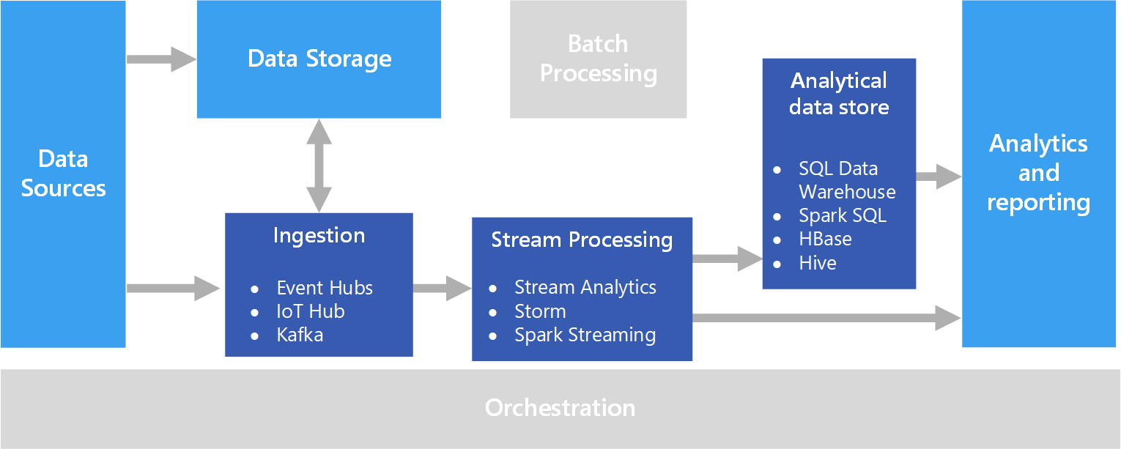

Figure 1 - https://docs.microsoft.com/en-us/azure/architecture/data-guide/scenarios/real-time-processing

We will have several components in our architecture:

1. Data Sources
   1. These are the Open vSwitch nodes sending NetFlow data.
2. Real-time Message Ingestion
   1. This component essentially performs Stream Buffering, providing the “Stream Processing” block enough time to process the stream data without being overrun with data.
   2. We will use Apache Kafka.
3. Stream Processing
   1. This component filters, aggregates, and prepares the data for analysis.
   2. We will use Apache Spark Streaming.
4. Analytical Data Store
   1. This is where the data is stored after being processed.
   2. We will use Elasticsearch.
5. Analytics and Reporting
   1. We will not use this part.
6. Machine Learning
   1. Not pictured in the above diagram.
   2. We will use the data in the Analytical data store to perform Machine Learning.

# **VM Parameters Used**

1. Memory: 6144MB (You may not need this much memory, I used a large value since all of the applications in this document are running in a single VM).
2. Hard Drive: 20GB

# **Pre-Requisites**

1. Install curl

sudo apt-get install curl

1. Install Java 8 onto Application VM
   1. Java8 commands:

sudo apt-get install software-properties-common -y && \

sudo add-apt-repository ppa:webupd8team/java -y && \

sudo apt-get update && \

echo "oracle-java8-installer shared/accepted-oracle-license-v1-1 select true" | sudo debconf-set-selections && \

sudo apt-get install oracle-java8-installer oracle-java8-set-default -y

1. Add JAVA_HOME to your .profile file and to PATH

vi ~/.profile

JAVA_HOME=/usr/lib/jvm/java-8-oracle

PATH=$PATH:$JAVA_HOME

1. Log out and back in to enable the changes.

# **Installing and Configuring Apache Kafka**

1. <https://kafka.apache.org/quickstart>
2. Download Kafka 1.0.0 (this is the version available in StreamSets)

cd ~

wget <http://apache.claz.org/kafka/1.0.0/kafka_2.11-1.0.0.tgz>

tar -xvzf kafka_2.11-1.0.0.tgz

1. Vi into the Kafka Server configuration file and update that file.

vi ~/kafka_2.11-1.0.0/config/server.properties

listeners=PLAINTEXT://streamsetApp:9092

advertised.listeners=PLAINTEXT://streamsetApp:9092

**NOTE:** streamsetApp is my VM hostname. You can find your hostname by running “hostname” in a terminal.

# **Installing and Configuring Apache Spark**

1. Download Apache Spark 2.3.0 to your VM. To choose your version you can go to <https://spark.apache.org/downloads.html>. Below is the mirror it gave me:

cd ~

wget <http://mirrors.ocf.berkeley.edu/apache/spark/spark-2.3.0/spark-2.3.0-bin-hadoop2.7.tgz>

tar -xzvf spark-2.3.0-bin-hadoop2.7.tgz

1. Go to the “conf” directory

cd ~/spark-2.3.0-bin-hadoop2.7/conf

1. Copy the spark-env template

cp spark-env.sh.template spark-env.sh

1. Add “MASTER=local[2]” to the end of the spark-env.sh file.

vi spark-env.sh

G # Go to end of file.

o # Add new line below current cursor position and enter insert mode.

MASTER=local[2]

Esc # switch out of insert mode.

:x # save and exit.

1. Place sparkKafka.py into ~/spark-2.3.0-bin-hadoop2.7/python/

# **Installing and Configuring Elasticsearch**

1. <https://www.elastic.co/downloads/elasticsearch>
2. Download the file:

cd ~

wget <https://artifacts.elastic.co/downloads/elasticsearch/elasticsearch-6.2.3.tar.gz>

tar -xvzf elasticsearch-6.2.3.tar.gz

# **Installing and Configuring StreamSets**

1. <https://streamsets.com/blog/visualizing-netflow-data-streamsets-data-collector-kudu-impala-d3/>
2. To simplify the flow between the different products, we can use Streamsets. <https://streamsets.com/opensource/>
3. Download the file:

cd ~

wget <https://archives.streamsets.com/datacollector/3.1.2.0/tarball/streamsets-datacollector-core-3.1.2.0.tgz>

tar -xvzf streamsets-datacollector-core-3.1.2.0.tgz

1. Increase the limit of open file descriptors.
   1. sudo vi /etc/security/limits.conf
   2. At the end of the file (above where it says # End of file) put the following entry:

* soft nofile 32768

* hard nofile 32768

1. Log out and back in for this to take effect.
2. You can verify this worked after logging back in by running “ulimit -n” and you should see 32768

# **Building Pipeline in StreamSets**

1. <https://streamsets.com/blog/visualizing-netflow-data-streamsets-data-collector-kudu-impala-d3/>
2. <https://kafka.apache.org/quickstart>
3. Run the Data Collector (from the directory you downloaded it in):

~/streamsets-datacollector-3.1.2.0/bin/streamsets dc

1. Go to http://<system-ip>:18630/
   1. Default username and password are “admin” and “admin”
2. Go to the packages icon  in the top right corner and install the following packages. Check the box next to the name of each package and then click  to install:
3. Apache Kafka 1.0.0
4. ~~CDH Spark 2.1.0 Release 1~~
5. ~~Elasticsearch 5.2.0~~
6. Create a new Pipeline for UDP to Kafka.
7. Name it “UDP Kafka Producer” with description “Source data from UDP to Kafka”
8. Run it on the “Data Collector”
9. Select Origin to be “UDP Source – Basic”
   * 1. In the Configuration Panel at the bottom, select the UDP tab and change the Data Format to NetFlow.
10. “Select Destination to connect” to Kafka Producer.
    * 1. In the Configuration Panel at the bottom, select the Kafka tab and change the “Topic” to “NETFLOW”
      2. In the Configuration Panel at the bottom, select the “Data Format” tab and change “Data Format” to “JSON Record”
11. Click the  icon. This will take you to “Error Records”. Select “Discard (Library: Basic)” from the drop-down menu.
12. ~~Create a new Pipeline for Kafka to Spark~~
    1. ~~Name it “Kafka to Spark” with description “Kafka to Spark”~~
    2. ~~Run it on the “Data Collector”~~
    3. ~~Select Origin to be “Kafka Consumer”~~
       1. ~~In the Configuration Panel at the bottom, select the Kafka tab and change the “Topic” to “NETFLOW”~~
       2. ~~In the Configuration Panel at the bottom, select the “Data Format” tab and change “Data Format” to “SDC Record”~~
    4. ~~Select Processor to be “Spark Evaluator – CDH Spark 2.1.0 Release 1”~~
       1. ~~In the Configuration Panel at the bottom, select the Spark tab and change:~~
          1. ~~“Application Name” to asdf~~
          2. ~~“Spark Transformer Class” to asdf~~
    5. ~~Select Destination to be “Elasticsearch – Elasticsearch 5.2.0”~~
       1. ~~In the Configuration Panel at the bottom, select the Elasticsearch tab and change:~~
          1. ~~Cluster HTTP URIs to asdf~~
          2. ~~Index to asdf~~
          3. ~~Mapping to asdf~~

# **Testing Current Pipeline**

1. Open a new terminal and launch StreamSets Web GUI (if not already running):

~/streamsets-datacollector-3.1.2.0/bin/streamsets dc

Go to <http://streamsetApp:18630/>

**NOTE:** streamsetApp is my VM hostname. You can find your hostname by running “hostname” in a terminal.

Default username/password is “admin” and “admin”

1. Open a new terminal and launch Spark Master and Slave servers:

cd ~/spark-2.3.0-bin-hadoop2.7/

sbin/start-master.sh

sbin/start-slave.sh spark://streamsetApp:7077

**NOTE:** streamsetApp is my VM hostname. You can find your hostname by running “hostname” in a terminal.

1. Open a new terminal and launch zookeeper server:

cd ~/kafka_2.11-1.0.0/

bin/zookeeper-server-start.sh config/zookeeper.properties

1. Open a new terminal and launch Kafka server:

cd ~/kafka_2.11-1.0.0/

bin/kafka-server-start.sh config/server.properties

1. Open a new terminal and create a Kafka Topic for NETFLOW:

cd ~/kafka_2.11-1.0.0/

bin/kafka-topics.sh --create --zookeeper localhost:2181 --replication-factor 1   
--partitions 1 --topic NETFLOW

1. List Kafka Topics to verify NETFLOW is there

cd ~/kafka_2.11-1.0.0/

bin/kafka-topics.sh --list --zookeeper localhost:2181

You should see NETFLOW in the output.

1. Run the StreamSets Pipeline. Open StreamSets and open your pipeline. Click 
2. Launch a Kafka Consumer Console to view the NETFLOW messages being received by Kafka.

cd ~/kafka_2.11-1.0.0/

bin/kafka-console-consumer.sh --zookeeper localhost:2181 --topic NETFLOW

1. Open a new terminal and launch your Python code for Spark Streaming

cd ~/spark-2.3.0-bin-hadoop2.7/

bin/spark-submit --packages org.apache.spark:spark-streaming-kafka-0-8_2.11:2.3.0 python/sparkKafka.py | grep -v INFO | grep -v WARN

NOTE: This command will install any missing packages and necessary JAR files.

1. Start ONOS (if not already started) in **ONOS VM**.

onos-buck run onos-local

1. Start Mininet (if not already started) in **Mininet VM**.

sudo mn --controller=remote,ip=10.28.34.39,port=6633

NOTE: 10.28.34.39 is the IP of my VM running ONOS.

1. Make sure Netflow is enabled on the switches (if not already enabled) in **Mininet VM**.

ovs-vsctl -- set bridge s1 netflow=@nf -- --id=@nf create NetFlow targets=\”10.28.34.17:9995\” active-timeout=60

NOTE: 10.28.34.17 is the IP of my StreamSets App VM.

1. Run a ping between 2 hosts in the **Mininet VM**.

h1 ping h2

1. You should now see Netflow messages in the kafka-console-consumer window. Example:

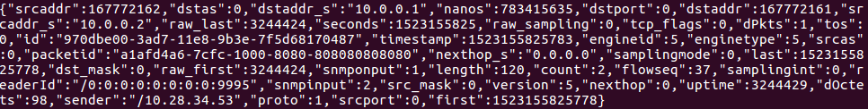

1. In StreamSets web GUI you should also see data showing up in the Summary window. Example:

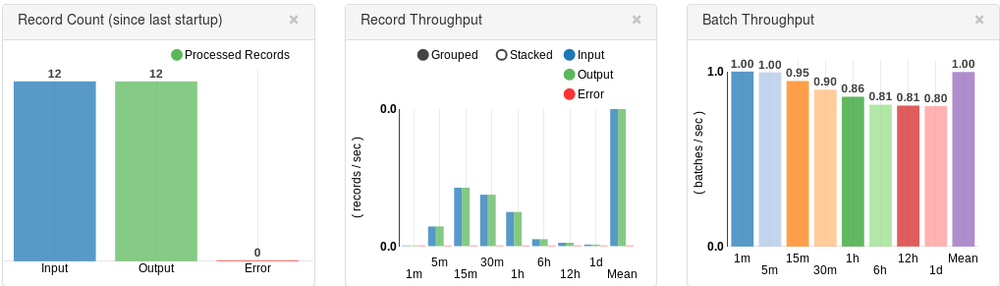

1. You should see JSON Output in your Spark Streaming terminal window.   
   NOTE: Due to buffering, it may take a few minutes to display the messages on the screen.  
     
   Example:

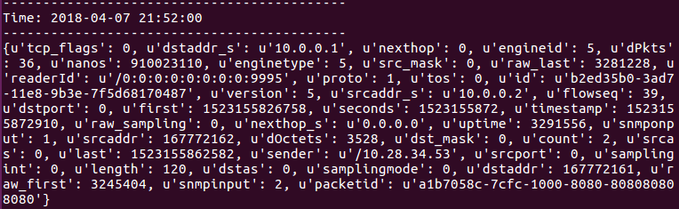

# **Stopping Current Pipeline**

1. **NOTE: It is important you run these in order. Otherwise some items will refuse to shut down.**
2. Ctrl-c to stop the Spark Streaming Python code.
3. Stop the Spark Master and Slave servers

cd ~/spark-2.3.0-bin-hadoop2.7/

sbin/stop-slave.sh

sbin/stop-master.sh

1. Ctrl-c to stop the kafka-console-consumer.
2. Stop the Kafka Server

cd ~/kafka_2.11-1.0.0/

bin/kafka-server-stop.sh

1. Stop the Zookeeper Server

cd ~/kafka_2.11-1.0.0/

bin/zookeeper-server-stop.sh

1. Stop the StreamSets Pipeline by clicking  and answering “Yes” to confirm stopping.

# **Spark Streaming Python Resources**

<https://www.rittmanmead.com/blog/2017/01/getting-started-with-spark-streaming-with-python-and-kafka/>

<https://www.rittmanmead.com/blog/2017/01/data-processing-and-enrichment-in-spark-streaming-with-python-and-kafka/>

# **ElasticSearch Python Resources**

<https://www.elastic.co/products/hadoop>

<https://www.elastic.co/guide/en/elasticsearch/hadoop/master/spark.html>